# NM2207

Week 1

# Challenges

# Navigating files and folders

Step 1. Make sure you have Chrome installed. If not, you can download it here.: [https://www.google.com/chrome/](http://www.google.com/chrome/)

Step 2. Download and install the sublime text editor. You will find it here: <http://www.sublimetext.com/>

A note on directory (“folder”) structure:

Directories are structured as “trees” with a name or letter for the root of a disk on your system. Here is a picture of such a tree (Windows Explorer and Mac Finder both have tree views):

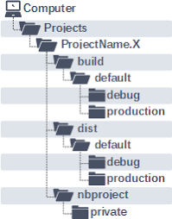

If you click on a particular directory, it “opens” and you are “in” it.

There are a couple of different ways to specify directories using text. One by typing out the “full path”, for example

* + C:/Projects/ProjectName.X/dist/default

and another is by using a “relative path” from the directory you are “in”. So if you are already in ProjectName.X, you could refer to the dist folder simply as

* + dist

since dist is located in the directory you are in.

Step 3. Open a (Explorer or Finder) window on your file system. Navigate to a location where you will do all your development for this class, and create a new folder (or “directory – same thing!). Let’s refer to it as nm2207dir (but you can name it whatever you want)

Step 4. Open a command line window (Command Window / Terminal) on your machine.

## You can also drag and drop folders to the command window to print their location. (Try using this to change directories with cd!)

* + **TAB completes partially typed commands if it can.**

Step 5. It is very important to master the basics of file navigation and command line usage, and to keep a nice clean directory structure for your class work code along, homeworks, and final project. Let’s practice using the command line:

1. print the name of the directory you are in.
2. navigate to nm2207dir using the command line specifying the relative path.
3. navigate back up to the “parent directory” using ..
4. navigate back to nm2207 specifying the full path (either my typing it manually, or by dragging that folder from Explorer/Finder on the command window after typing ‘cd’.

Command line commands for your reference:

1. “foo” and “bar” are example names of **directories**. You can call yours something else. Directories mean the same thing as folders. They are used interchangeably.
2. “foofile” and “barfile” are example names of **files**. You can call yours something else.
3. The command in brackets and a question mark e.g., (ls?) means “What happens when you try this command?”
4. Avoid creating names with space in them “my.file” is better than “my file”!

|  |  |  |
| --- | --- | --- |
|  | **MAC & Linux** | **WINDOWS (DOS)** |
| **Navaigate to a file path** | **cd fullfilepath** | **cd fullfilepath** |
| **Show files in folder** | **ls** | **dir (ls?)** |
| Make a directory | mkdir foo | mkdir foo |
| Change directory to foo | cd foo | cd foo |
| Make a directory | mkdir bar | mkdir bar |
| Show files in folder | ls | dir (ls?) |
| Change to child directory ie bar from foo | cd bar | cd bar |
| (. means this directory, .. means the “parent”  directory) |  |  |
| Change to parent directory ie foo from bar | cd .. | cd .. |
| Create a new file called foofile.html (first confirm that you are in the foo directory) | subl ./foofile.html  (Follow instructions at the bottom of <https://nm2207.org/creativeweb/Setup.html> to get this to work properly) | subl ./foofile.html  (Follow instructions at the bottom of <https://nm2207.org/creativeweb/Setup.html> to get this to work properly) |
| Show files in folder | ls | dir (ls?) |
| Delete file | rm foofile.html | del foofile.html |
| Copy a file to a directory | cp foofile.html bar | copy (cp ?) foofile.html bar |
| Move a file to a directory | mv foofile.html bar | move (mv?) foofile.html bar |
| Delete a directory foo | rmdir foo | rmdir foo |
| Show contents of text files on screen | cat foofile.html (less foo) | type foofile.html |
| Open an text file which is in the same directory in a browser | open ./foofile.html | foofile.html |
| Open a text file which is in one level up directory in the browser | open ../foofile.html | ../foofile.html |

# Create a Homepage

Step 6. Now lets explore index.html

1. Open index.html in the browser.
   * Right click->Open in browser
   * Or in the address box in your browser, type file:// followed by the whole directory path to the file
   * Or, in the File Explorer (where you view the contents of Session01.class, double click the index.html file. If your default browser is set to Google Chrome, then it will open in Google Chrome. If it is not, then search the internet for how to set your default browser to Google Chrome in Windows or Mac.
   * Or, you can also open Google Chrome and then drag the file icon for index.html from your File Explorer into an open Chrome browser window, to open it.
2. Open index.html in the SublimeText editor
   * Start sublime (probably easiest to double-click the icon)
   * Open the Session01.class folder in sublime (drag the folder into sublime, or use File->Open Folder)
   * Show the contents of the file index.html in the Sublime editor

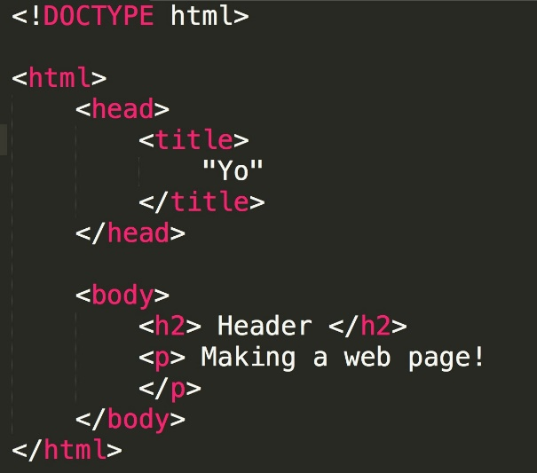

1. Look up each of the “tags” in red at <https://www.w3schools.com/TAGS/default.ASP> by using the search bar under “HTML Tags ordered alphabetically.”

What do they mean? The first two are provided as some background information.

|  |  |
| --- | --- |
| **Tag** | **Meaning** |
| **HTML** | **Hyper Text Markup Language, the language used to write webpages.** |
| **HTML document** | **A document written in HTML, like your index.html file** |
| <html> | Tag represents the root of an HTML document and is also the container for all other HTML elements |
| <head> | element is a container for metadata (data about data) and is placed between the <html> tag and the <body> tag. |
| <title> | tag defines the title of the document. The title must be text-only, and it is shown in the browser's title bar or in the page's tab. |
| <body> | tag defines the document's body. |
| <h2> | tags are used to define HTML headings. |
| <p> | tag defines a paragraph. |

++++++

Step 7. In your browser with your web page open, right click -> View Page Source

Step 8. Back at your web page, Menu (3 dots in upper right) -> More Tools ->

Developer Tools

1. Go to the ‘Elements’ tab
2. Click on (and draw your mouse over) each of the components. What happens on the page?
3. Check out the Sources tab and open your file from there.

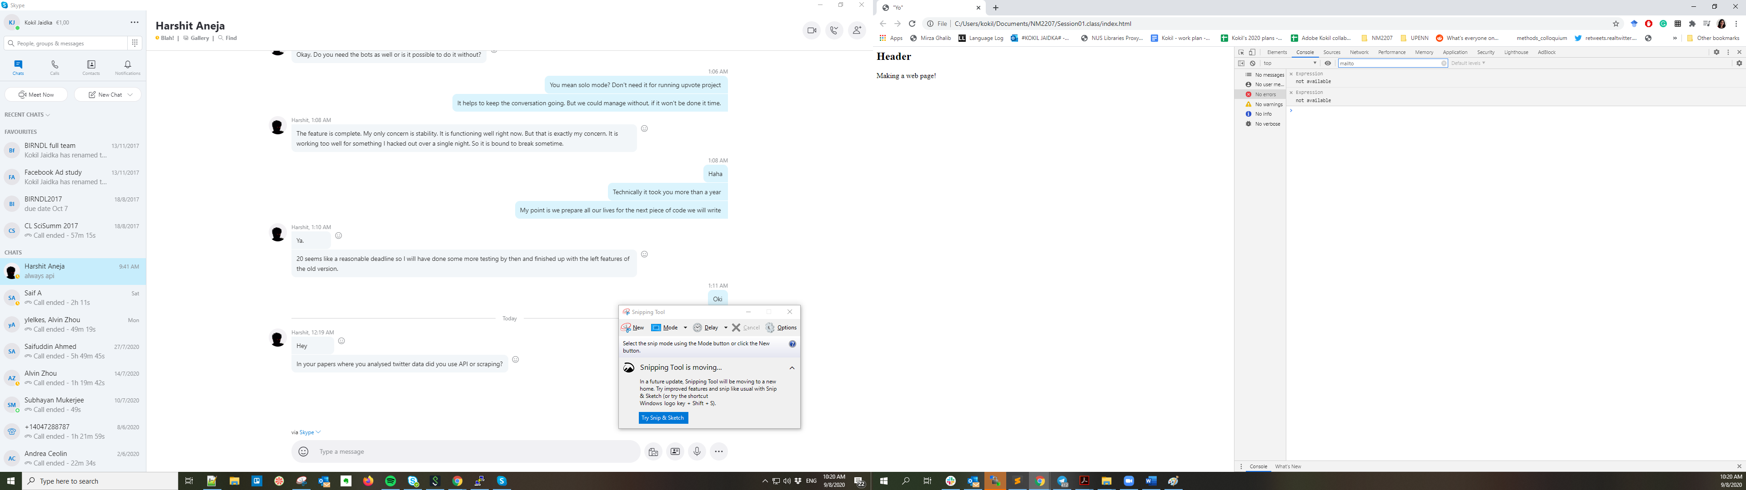

Step 9. Open the console tab

Type “var x = 5;” and press the enter key

Type “x” and press the enter key. What happens?

Type “x +2” and press the enter key. What happens?

# Set up FileZilla

Now we need some program to help us upload our web pages to this machine so that they can be served. We’ll use the “file transfer” (FTP) program FileZilla for that (if you already have an ftp program on your machine you are comfortable with, you don’t need this)

Step 10. Download and install the the FileZilla FTP program. You will find it here: https://filezilla-project.org/

Download the Client (not the Server).

Open FileZilla and enter the hostname (nm2207.org) your userid, password in the fields at the top of the window. The “port” field should be 22.

**Your username is your NUS userid,**

**Your password is Creative…Coding, where “…” is your userid (the one that starts with A0)**

The window on the right will open in your home directory on nm2207.org. Navigate to your ‘web’ folder. ***Anything you put in this folder will be visible on the web.***

***Note:*** *never delete or replace the web folder itself – only do that for files and folder inside web/*

(Don’t close FileZilla yet)

Now, you can use FileZilla to upload the folders that have your homework in them from your **local** machine to your home directory on nm2207.org.

Step 11. Open a browser and navigate it to: https://nm2207.org/2021I/[your user id]/web/

Does it work? Important: Why or why not? Discuss with your partners to make sure you understand what is happening.

Step 12. Navigate your browser to your neighbor’s home page, too!

Step 13. On FileZilla, rightclick and rename the index.html file in your web folder to index_original.html. Now, navigate the left side window so that it shows the folder you have been working on and the files within it. Now, drag your newly-created index.html file there from your local folder.

